Supplementary Information for the manuscript titled:
Performance Assessment of Various Graph Neural Network Architectures for Predicting Yield in Cross-Coupling Reactions
Figure S1. Categories of first-row transition metal-catalyzed cross-coupling reactions considered in this study. The dataset includes a diverse array of molecules such as biaryls, 1,3-diynes, ethers, thioethers, aryl halides, amines, and related structural analogues.

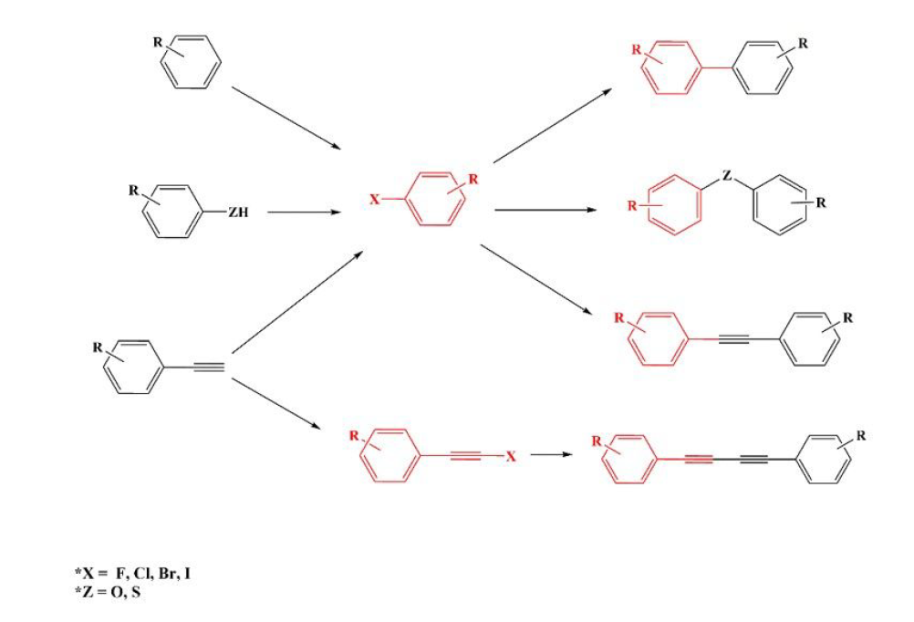
X= F, Cl, Br, I
Z= O, S, NH

Figure S2. Comparison of Root Mean Square Error (RMSE) and Mean Absolute Error (MAE) values across different GNN models

for yield prediction in transition metal-catalyzed cross-coupling reactions.

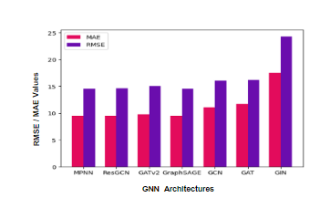

Table S1. Comparison of graph-based models (GAT, GCN, GIN, and GraphSAGE) evaluated under various hyperparameter configurations. Performance metrics (R², RMSE, MAE) are reported for different combinations of learning rates (0.001, 0.0002, 0.005), epochs (50, 100), and hidden dimensions (32, 64, 128).

MODEL | EPOCHS | 0.001 | TEST R2 | TRAIN R2 | 0.002 | TEST R2 | TRAIN R2 | 0.005 | TEST R2 | TRAIN R2
MPNN |  | 32 | 0.47 | 0.57 | 32 | 0.68 | 0.86 | 32 | 0.743 | 0.90
 | 50 | 64 | 0.7492 | 0.90 | 64 | 0.7491 | 0.89 | 64 | 0.747 | 0.90
 |  | 128 | 0.738 | 0.89 | 128 | 0.7506 | 0.90 | 128 | 0.7437 | 0.9029
 | 100 | 32 | 0.74 | 0.89 | 32 | 0.7458 | 0.90 | 32 | 0.74 | 0.90
 |  | 64 | 0.749 | 0.90 | 64 | 0.747 | 0.90 | 64 | 0.748 | 0.90
 |  | 128 | 0.748 | 0.90 | 128 | 0.748 | 0.905 | 128 | 0.747 | 0.906

ResGCN |  | 32 | 0.75 | 0.93 | 32 | 0.74 | 0.92 | 32 | 0.75 | 0.93
 | 50 | 64 | 0.741 | 0.91 | 64 | 0.747 | 0.93 | 64 | 0.748 | 0.937
 |  | 128 | 0.7488 | 0.93 | 128 | 0.7488 | 0.93 | 128 | 0.7480 | 0.93
 | 100 | 32 | 0.7480 | 0.93 | 32 | 0.7487 | 0.93 | 32 | 0.7490 | 0.93
 |  | 64 | 0.7481 | 0.9356 | 64 | 0.7488 | 0.9362 | 64 | 0.7489 | 0.9374
 |  | 128 | 0.7485 | 0.9369 | 128 | 0.7487 | 0.9377 | 128 | 0.7483 | 0.93
GraphSAGE |  | 32 | 0.736 | 0.902 | 32 | 0.7502 | 0.931 | 32 | 0.7511 | 0.933
 | 50 | 64 | 0.7494 | 0.93 | 64 | 0.7499 | 0.9365 | 64 | 0.7486 | 0.9373
 |  | 128 | 0.748 | 0.937 | 128 | 0.747 | 0.936 | 128 | 0.7501 | 0.939
 | 100 | 32 | 0.748 | 0.934 | 32 | 0.749 | 0.938 | 32 | 0.7488 | 0.9396
 |  | 64 | 0.7491 | 0.9368 | 64 | 0.7492 | 0.9380 | 64 | 0.7493 | 0.9392
 |  | 128 | 0.7494 | 0.9378 | 128 | 0.7492 | 0.9393 | 128 | 0.7480 | 0.9402
GCN |  | 32 | -1.3340 | -1.2635 | 32 | -1.47 | -1.41 | 32 | 0.53 | 0.65
 | 50 | 64 | -1.7112 | -1.6576 | 64 | 0.5126 | 0.6395 | 64 | 0.6993 | 0.8166
 |  | 128 | 0.273 | 0.399 | 128 | 0.709 | 0.812 | 128 | 0.71 | 0.824
 | 100 | 32 | -0.1688 | -0.0540 | 32 | 0.6064 | 0.7313 | 32 | 0.7130 | 0.8259
 |  | 64 | -0.4660 | -0.3612 | 64 | 0.7140 | 0.8258 | 64 | 0.7136 | 0.8261
 |  | 128 | 0.7027 | 0.8190 | 128 | 0.7139 | 0.8261 | 128 | 0.7147 | 0.8264
GAT |  | 32 | 0.3839 | 0.5144 | 32 | 0.7041, | 0.8682 | 32 | -0.0850 | 0.0183
 | 50 | 64 | 0.6904 | 0.8519 | 64 | 0.0717 | 0.1834 | 64 | 0.2450 | 0.3636
 |  | 128 | 0.4326 | 0.5665 | 128 | 0.6722 | 0.8302 | 128 | 0.3225 | 0.4456
 | 100 | 32 | 0.4437 | 0.5782 | 32 | -0.2331 | -0.1351 | 32 | 0.0318 | 0.1371
 |  | 64 | 0.6675 | 0.8251 | 64 | -0.0116 | 0.0944 | 64 | 0.6710 | 0.8298
 |  | 128 | 0.4708 | 0.6068 | 128 | 0.4946 | 0.6313 | 128 | 0.6562 | 0.8118
GATV2 |  | 32 | 0.59 | 0.74 | 32 | 0.74 | 0.92 | 32 | 0.73 | 0.91
 | 50 | 64 | 0.74 | 0.92 | 64 | 0.72 | 0.89 | 64 | 0.73 | 0.90
 |  | 128 | 0.74 | 0.92 | 128 | 0.73 | 0.90 | 128 | 0.7068 | 0.91
 | 100 | 32 | 0.73 | 0.90 | 32 | 0.62 | 0.84 | 32 | 0.66 | 0.87
 |  | 64 | 0.71 | 0.91 | 64 | 0.73 | 0.90 | 64 | 0.72 | 0.93
 |  | 128 | 0.744 | 0.9251 | 128 | 0.75 | 0.9367 | 128 | 0.719 | 0.923
GIN |  | 32 | 0.4288 | 0.5085 | 32 | 0.4897 | 0.5336 | 32 | 0.4820 | 0.5355
 | 50 | 64 | 0.5240 | 0.5657 | 64 | 0.5420 | 0.6021 | 64 | 0.4453 | 0.5181
 |  | 128 | 0.5354 | 0.5779 | 128 | 0.5081 | 0.5482 | 128 | 0.4510 | 0.5175
 | 100 | 32 | 0.4562 | 0.5570 | 32 | 0.4655 | 0.5620 | 32 | 0.4585 | 0.5479
 |  | 64 | 0.5008 | 0.5962 | 64 | 0.5293 | 0.5714 | 64 | 0.5164 | 0.5500
 |  | 128 | 0.5076 | 0.6016 | 128 | 0.5416 | 0.5936 | 128 | 0.4920 | 0.5308

Figure S2. Scatter plots showing predicted versus experimental reaction yields for each graph-based model (GAT, GCN, GIN, GraphSAGE) using their respective optimized hyperparameters. Each model was trained and evaluated under various configurations of learning rate(0.001,0.002,0.005), number of epochs(50,100), and hidden layer dimensions(32,64,128).

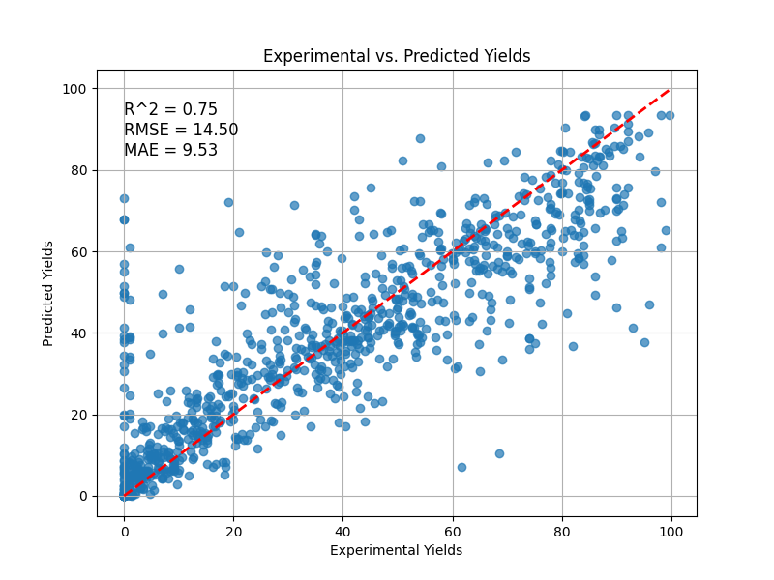
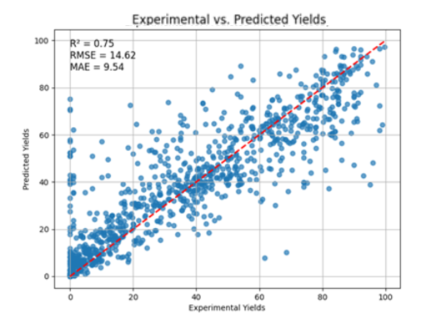
- MPNN (B) RESGCN

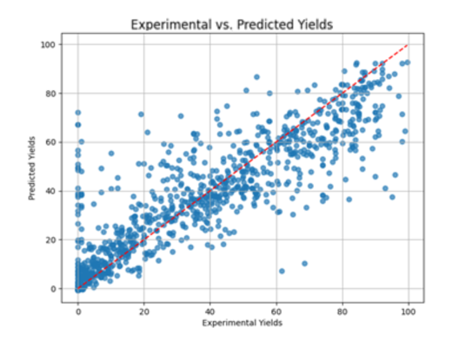
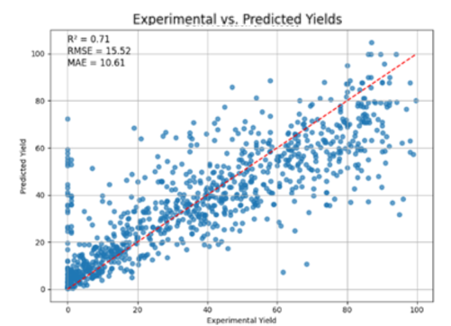
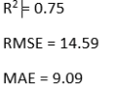
- GraphSAGE (D) GCN
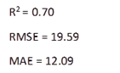

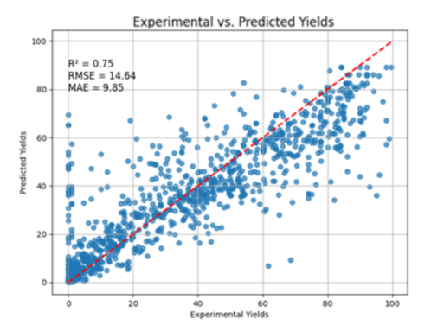
(E) GATV2 (F) GAT

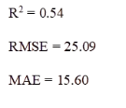

(G) GIN

